Check List for APA 7 Format in Microsoft Word

- Margins at 1” top, bottom, left & right (Layout, Margins)
- Make default font Times New Roman and default font size 12 (Home, Font Dialog Box Launcher)

Change font to Times New Roman and font size to 12, click on Set As Default Button)
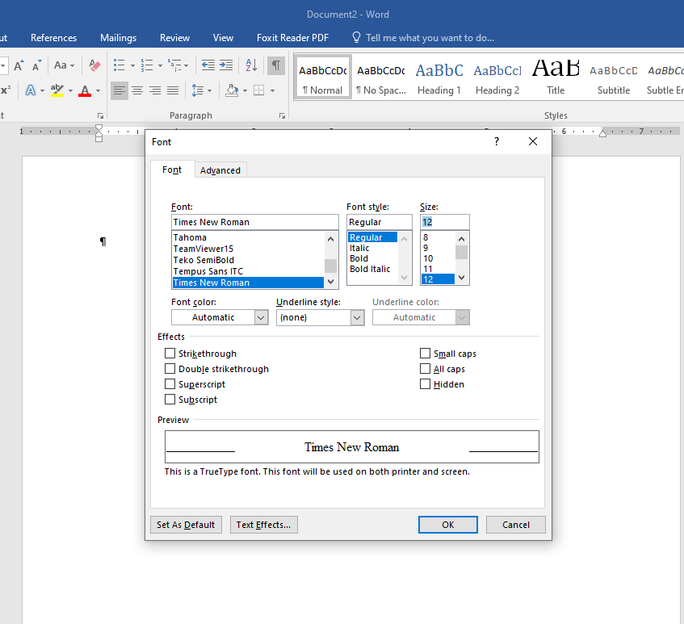

- Make default line spacing double and default paragraph spacing 0 for both spacing before and after (Home, Paragraph Dialog Box Launcher)

Change line spacing to Double and paragraph spacing after to 0, click on Set As Default Button)
- Header – (Insert, Page Number, Top of Page, Plain Number 3)
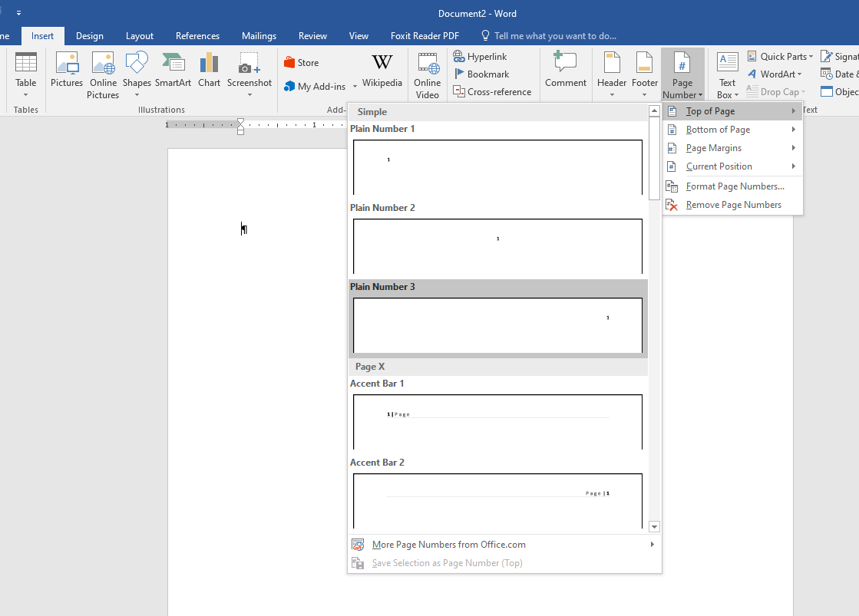
Close Header and Footer

- Type the Title Page for the paper. (Leave about four blank lines at the top of the page)
All text for the Title Page to be centered. (Click on Center button in the Paragraph section of Home ribbon)

- The paper’s title should be bold. Author’s name appears 2 line after the title. Author’s name followed by Department and School, then the course number and name, then the instructor’s name, and then the assignment’s due date. See example below:

- To begin a new page (Insert, Page Break) or (Ctrl Enter)
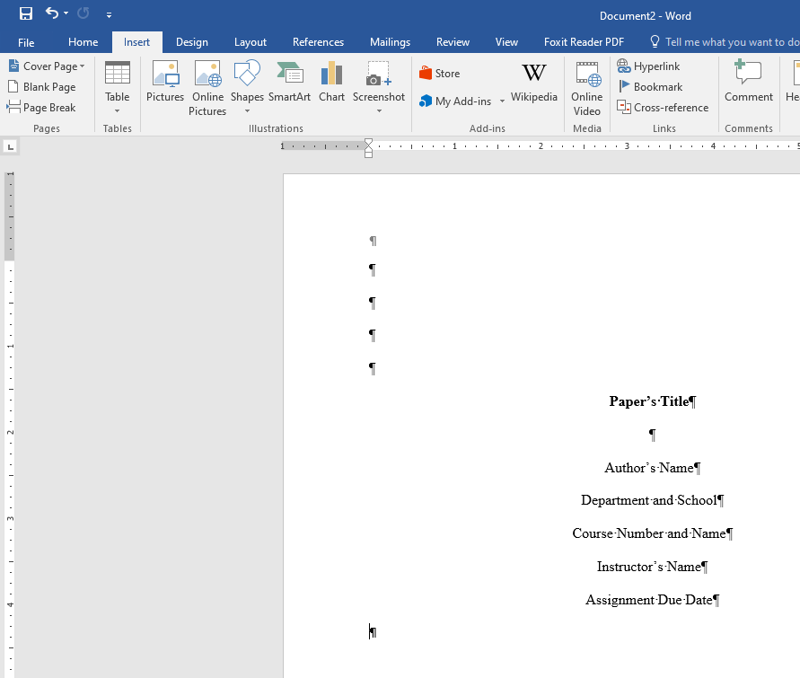
- Type the paper’s title at the top center of the page. Continue typing paper at the left margin. (Click on Left button in the Paragraph section of Home ribbon)

- The Reference Page is at the end of your paper. The title References appears in the center at the top of the reference page. (Click on Center button in the Paragraph section of Home ribbon)

- Use a Hanging Indent for your references on the Reference page. (Home, Paragraph Launcher
(Special) or (Ctrl T)

NOTE: Use a Left Indent for long quotes. (Home, Paragraph Dialog Box Launcher, Indentation, Left at .5) You can also use the Increase Indent button on the Home ribbon. Remember to decrease the left indent after you finish the quote and have pressed Enter.

Additional information can be found at the Purdue Online Writing Lab:

https://owl.purdue.edu/owl/research_and_citation/apa_style/apa_formatting_and_style_guide/general_format.html

